\*\***Docker Documentation (Ajay Initial Discussion)**

1) Initial Launch an EC2 instance

2)Open Putty :

>> sudo su

>> sudo yum update

>> sudo yum install docker –y

>> ps –ef|grep -i docker

>> sudo service docker start

>>sudo ps

>>sudo docker

>> sudo docker pull ubuntu

>> sudo docker pull centos

>> sudo docker pull java

>> sudo docker pull httpd

>> docker run ubuntu

>> docker run centos

>> docker run java

>> docker run httpd

>> docker ps

>> docker images

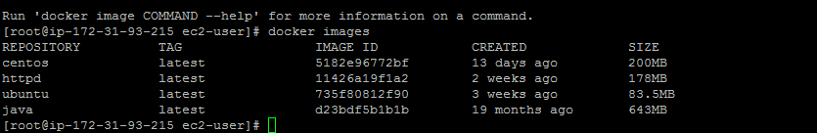

>> docker pull nginx

>> docker pull busybox

>> docker pull alpine

>> docker run –d busybox

>> docker run –td busybox

>> docker run –d alpine

>> docker run –td alpine

>> docker ps

>> docker stop container id

>> docker run -it alpine /bin/sh

* -it : I is interactive and t is for terminal
* df –h : to see file system
* To exting from container : ctrl+p+q (Without Killing it)

>> docker run –it alpine ping localhost

>> docker ps

>> docker images

>> docker stop “**containerid**”

>> docker ps –a : To see history of all the process we have done so far.

>> docker start “**containerid**” : to start process available in ps –a.

>> docker kill “**containerid**” : to kill or remove permanently that process.

________________________________________________

**For Alpine Config**

>>docker run alpine

>>docker ps

>> docker export “alpinecontainerid” –o alpine.tar

>> ls –l

>> tar –tvf alpine.tar

>>docker import alpine.tar

>>docker inspect “alpinecontainerid”

**TO see File System Details:**

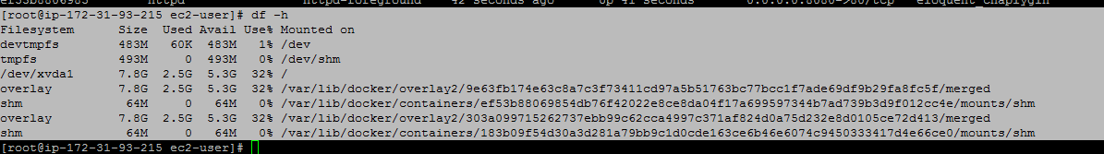

**To Run A command inside a container:**

* docker exec -it c7ec5744fc08 hostname
* docker exec -it c7ec5744fc08 ps –ef